Reconciliation Report for Qube Active Tenancies
Version 1 | 09/04/2025

Grainger PLC
Single View of Tenancy

Contents
Tenancies: 3
Breakdown of migrated tenancies: 3
Opportunities: 4
Breakdown of parented Opportunities: 4
Contracts: 5
Breakdown of parented Contracts: 5
EOTs: 6
Breakdown of parented EOTs: 6

Tenancies:

Delta 0 unaccounted for Records
Tenancies excluded from migration: 33669

Breakdown of migrated tenancies:

Total active tenancies in Qube extract: 44729

Tenancies excluded due to:
• Duplicate parent references in Qube: 18547
• Duplicate unit IDs in Qube: 9861
• Missing unit in UAT: 5261

Total tenancies migrated into UAT: 11060

Total active tenancies present in Qube extract: 44729
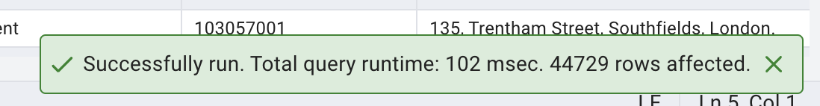

Tenancies excluded due to duplicate parent references in Qube extract: 18547
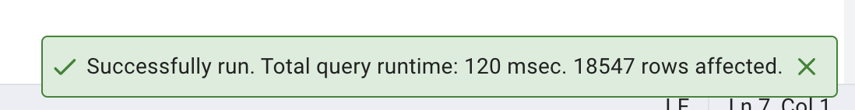

Tenancies excluded due to duplicate unit ID in Qube extract: 9861
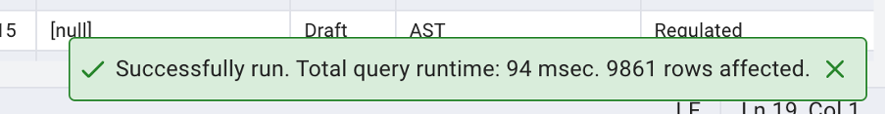
Tenancies excluded due to missing unit in UAT: 5261
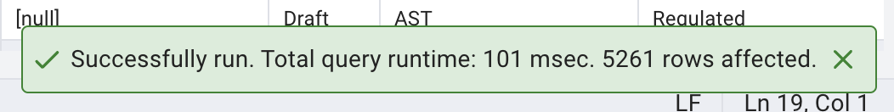

Total Tenancies migrated into UAT: 11060
UAT
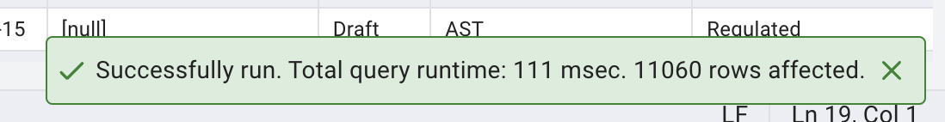
Salesforce


Opportunities:
Delta 0 unaccounted for Records.
Unparented Opportunities: 27571

Breakdown of parented Opportunities:

Total Opportunities in UAT : 42291

Opportunities Parented by:
• PMS Reference ID: 1567
• Unit ID: 13153

Total Opportunities parented to Tenancies in UAT: 14720

Total Opportunities in UAT: 42291
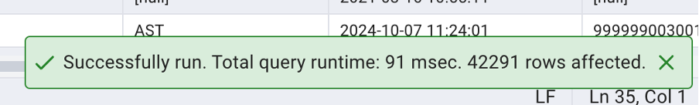

Opportunities parented by PMS Reference ID in UAT: 1567
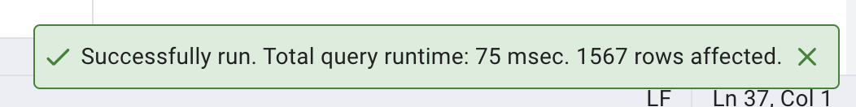
Opportunities parented by Unit in UAT: 13153
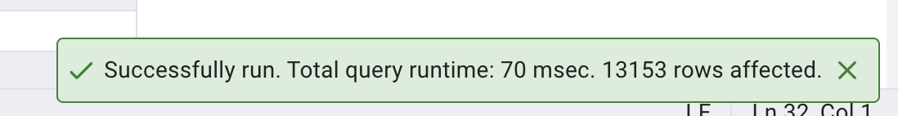

Total parented Opportunities in UAT: 14720
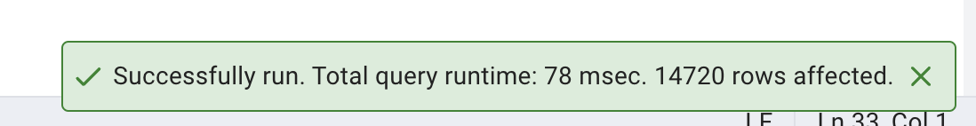

Contracts:
Delta 0 Unaccounted for Records
Unparented Contracts: 20325

Breakdown of parented Contracts:

Total Contracts in UAT: 31975

Contracts excluded due to:
• Missing PMS Reference ID : 20325

Total Contracts parented to Tenancies in UAT: 11650

Total contracts in UAT: 31975
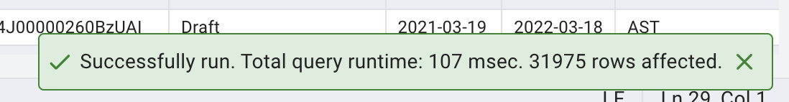
Total contracts excluded do to no PMS reference id:
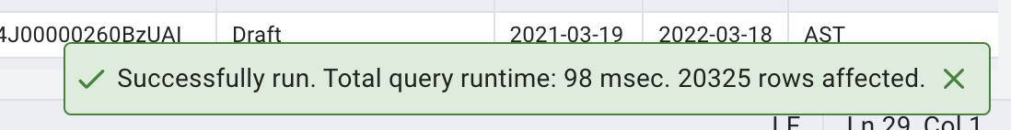
Total Contracts matched to opps parented to a tenancy:
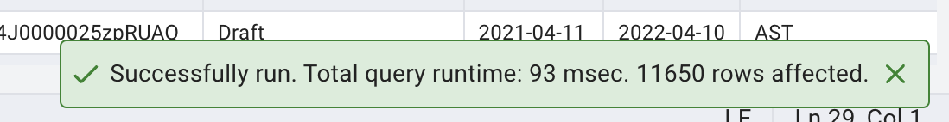

EOTs:

Delta 0 Unaccounted for Records:
Unparented EOTs: 1261

Breakdown of parented EOTs:

Total EOTs in UAT: 1583

EOTs excluded due to:
• Not matching parented contracts in UAT: 622
• No active Tenancy in UAT: 599

Total EOTs parented to a Tenancy in UAT: 322

Total EOTs in UAT: 1583
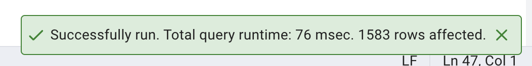
EOTs excluded due to not matching parented contracts: 662
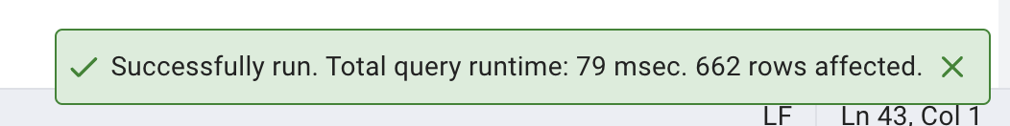
EOTs excluded due to no active tenancy: 599
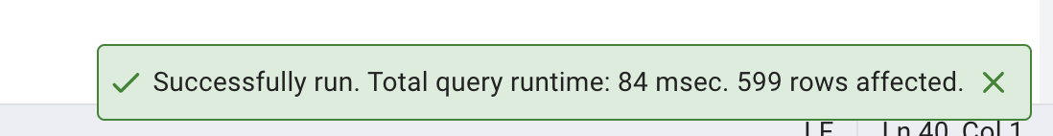
EOTs Parented to an active tenancy: 322
